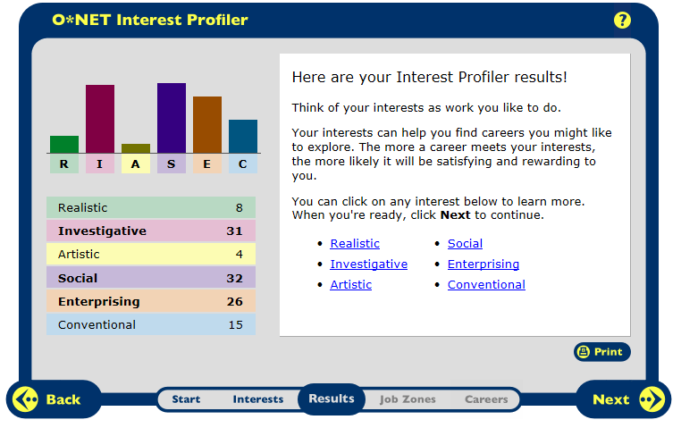
The three top categories are Investigative, Social, and Enterprising. Investigative says that people like work that has to do with ideas and thinking rather than physical activity or leading people. Some of this is true and some of it isn’t. I like to do things that require a lot of thinking and that I need to formulate my own ideas on how things work and figuring out problems. It isn’t true because I am very athletic. I love playing sports and exercising and I love to lead people in my sports and activity.
Social says that people like working with others to help them learn and grow. They like working with people more than working with machines. This is true for me because I love working with people. I love helping them with their problems and just being there for them. I also like working with machines like computers but not nearly as much as I like dealing with people. I am definitely a people person.
People with enterprising interests like work that has to do with starting up and carrying out business projects. People like taking action more than thinking about things. I over analyze everything but I would rather take action then sit around and wait. So this area of interest half makes sense for me and half doesn’t make sense.
Career Research Data for 4 Career Occupations
Career Research Questions: | 1st Career: Biological Scientist | 2nd Career: Teacher | 3rd Career:  Lawyer | 4th Career: Microbiologist
HR1. Occupation Defination | Biochemists and biophysicists study the chemical and physical principles of living things and of biological processes such as cell development, growth, and heredity. | Kindergarten and elementary school teachers prepare younger students for future schooling by teaching them the basics of subjects such as math and reading. | Lawyers advise and represent individuals, businesses, or government agencies on legal issues or disputes. | Microbiologists study the growth, development, and other characteristics of microscopic organisms such as bacteria, algae, and fungi.
HR2. Related Occupations | agriculture and food scientist, biological technicians, chemist and material scientists | High school teacher, principal, college professor | Judges, Mediators, and Hearing Officers, Paralegals and Legal Assistants, Postsecondary Teachers | Agricultural and Food Scientists, Biochemists and Biophysicists, Epidemiologists
HR3. Compatible Personality Types | Investigative | Social | Enterprising | Investigative
HR4. Education/Training/ Qualifications required | doctoral or professional degree, no on job training | Bachelor’s degree, Internship/residency | Doctoral or professional degree | Bachelor’s degree
HR5. Technology Skills Needed | Computer and machinery knowledge | None needed | None needed | Computer and machinery knowledge
RC1. Entry Level Average Salary | $79,390 per year | $51,380 per year | $112,760 per year | $65,920 per year
RC2. 10 yr. Projected Job Growth | 31% | 17% (About as fast as average) | 10% (About as fast as average) | 13% (About as fast as average)
RC3. Organizations that hire for this occupation | College labs, private companies | Schools | Private or corporate legal offices | College labs, private companies, hospitals
ISC1. Working Conditions | Laboratories and offices | Schools | Offices | Laboratories and offices
ISC2. Part of a Union (Y/N)? | No | Yes | No | No
ISC3. What Kind of Advancement Opportunities are There? | Promoted to head researcher with experience | Different pay grades based on how many years you are there | Get promoted within the law firm | Promotions and pay raises
ISC4. Universities/ Colleges/ Specialized Training Organizations | Northwestern University, Vanderbilt University, Yale University | Bridgewater State University, Framingham State University, UMASS Dartmouth | University of Connecticut, UMASS Amherst, UMASS Dartmouth | UMASS Amherst, University of New Hampshire, University of Rhode Island

